**Task 01**

**#include<iostream>**

**using namespace std;**

**int main()**

**{**

**int size;**

**cout<<"Enter the size of array --> ";**

**cin>>size;**

**int array_1[size];**

**for(int i=0; i<size; i++)**

**{**

**cout<<"Enter the number-->";**

**cin>>array_1[i];**

**}**

**cout<<"\n\nThe numbers in the Reverse Order are : \n";**

**for(int j=(size-1); j>=0; j--)**

**{**

**cout<<array_1[j]<<" ";**

**}**

**return 0;**

**}**

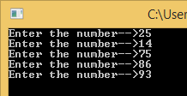

**Task 02**

**#include<iostream>**

**using namespace std;**

**int main()**

**{**

**int value,size,sum=0;**

**cout<<"Enter the size of an array you wonder --> ";**

**cin>>size;**

**int array_1[size];**

**for(int i=0; i<size; i++)**

**{**

**cout<<"Enter the number --> ";**

**cin>>array_1[i];**

**value=array_1[i];**

**sum+=value;**

**}**

**cout<<"\n\nThe sum of the all values in the array is --> "<<sum<<endl;**

**return 0;**

**}**

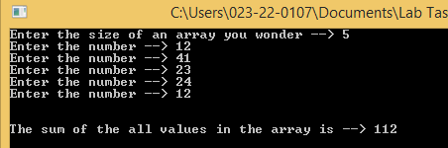

**Task 03**

**#include<iostream>**

**using namespace std;**

**int main()**

**{**

**double average=0,sum=0;**

**int avg[10]={22,12,56,14,47,89,13,12,45,36};**

**for(int i=0; i<9; i++)**

**{**

**sum+=avg[i];**

**average=sum/10;**

**}**

**cout<<"\n\nThe average of the elements in array is --> "<<average<<endl;**

**return 0;**

**}**

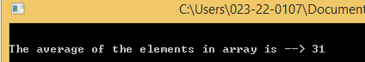

**Task 04**

**#include<iostream>**

**using namespace std;**

**int main()**

**{**

**int array_1[5]={2,63,54,24,7};**

**int array_2[5];**

**for(int i=0; i<5; i++)**

**{**

**array_2[i]=array_1[i];**

**}**

**cout<<"Values in the first array are : \n";**

**for(int i=0; i<5; i++)**

**{**

**cout<<array_1[i]<<" ";**

**}**

**cout<<"\nValues in the Second array are : \n";**

**for(int j=0; j<5; j++)**

**{**

**cout<<array_2[j]<<" ";**

**}**

**return 0;**

**}**

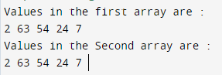

**Task 05**

**#include<iostream>**

**using namespace std;**

**int main()**

**{**

**int size;**

**cout<<"Enter the array size you wonder --> ";**

**cin>>size;**

**int even_array[size];**

**for(int i=0; i<size; i++)**

**{**

**cout<<"\nEnter the number -->";**

**cin>>even_array[i];**

**}**

**cout<<"\nEven numbers in the array are : \n";**

**for(int j=0; j<size; j++)**

**{**

**if(even_array[j]%2==0)**

**{**

**cout<<even_array[j]<<" ";**

**}**

**}**

**return 0;**

**}**

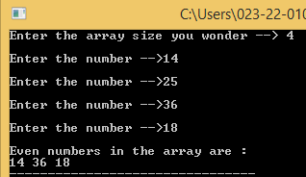

**Task 06**

**#include<iostream>**

**using namespace std;**

**int main()**

**{**

**int size;**

**cout<<"Enter the array size you wonder --> ";**

**cin>>size;**

**int even_array[size];**

**for(int i=0; i<size; i++)**

**{**

**cout<<"\nEnter the number -->";**

**cin>>even_array[i];**

**}**

**cout<<"\nODD numbers in the array are : \n";**

**for(int j=0; j<size; j++)**

**{**

**if(!(even_array[j]%2==0))**

**{**

**cout<<even_array[j]<<" ";**

**}**

**}**

**return 0;**

**}**

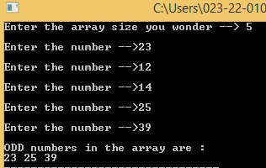

**Task 07**

**#include<iostream>**

**using namespace std;**

**int main()**

**{**

**int size;**

**cout<<"Enter the size of the array --> ";**

**cin>>size;**

**int array_1[size];**

**int array_2[size];**

**for(int i=0; i<size; i++)**

**{**

**cout<<"Enter the number --> ";**

**cin>>array_1[i];**

**}**

**for(int j=(size-1); j>=0; j--)**

**{**

**array_2[j]=array_1[(size-1)-j];**

**}**

**cout<<"\nElements in the first array : \n";**

**for(int a=0; a<size; a++)**

**{**

**cout<<array_1[a]<<" ";**

**}**

**cout<<"\nElements in the second array : \n";**

**for(int b=0; b<size; b++)**

**{**

**cout<<array_2[b]<<" ";**

**}**

**return 0;**

**}**

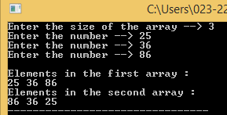

**Task 08**

**#include<iostream>**

**using namespace std;**

**int main()**

**{**

**int array_1[4]={22,45,12,3};**

**int array_2[4]={12,13,4,45};**

**int array_3[4];**

**for(int i=0; i<4; i++)**

**{**

**array_3[i]=array_1[i]+array_2[i];**

**}**

**cout<<"\nValues in the first array are below : "<<endl;**

**for(int a=0; a<4; a++)**

**{**

**cout<<array_1[a]<<" ";**

**}**

**cout<<"\nValues in the Second array are below : "<<endl;**

**for(int b=0; b<4; b++)**

**{**

**cout<<array_2[b]<<" ";**

**}**

**cout<<"\nValues in the third array are below : "<<endl;**

**for(int c=0; c<4; c++)**

**{**

**cout<<array_3[c]<<" ";**

**}**

**return 0;**

**}**

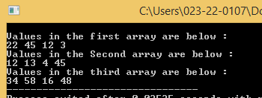

**Task 09**

**#include<iostream>**

**#include<string>**

**using namespace std;**

**int main()**

**{**

**int array_1[4]={22,44,66,67};**

**int array_2[5]={23,45,67,68,12};**

**int array_3[9];**

**cout<<"Values of first array are : ";**

**for(int a=0; a<4; a++)**

**{**

**cout<<array_1[a]<<" ";**

**array_3[a]=array_1[a];**

**}**

**cout<<"\n";**

**cout<<"Values of Second array are : ";**

**for(int b=0; b<5; b++)**

**{**

**cout<<array_2[b]<<" ";**

**array_3[b+4]=array_2[b];**

**}**

**cout<<"\n";**

**cout<<"Values of Third array are : ";**

**for(int c=0; c<9; c++)**

**{**

**cout<<array_3[c]<<" ";**

**}**

**return 0;**

**}**

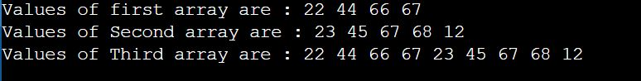

**Task 10**

**#include<iostream>**

**#include<string>**

**using namespace std;**

**int main()**

**{**

**int size;**

**cout<<"How many Students do you want --> ";**

**cin>>size;**

**string name[size];**

**double pf[size];**

**double ps[size];**

**double ict[size];**

**double eng[size];**

**double obt[size];**

**double per[size];**

**char grade[size];**

**for(int a=0; a<size; a++)**

**{**

**cout<<"Enter the name of Student "<<a+1<<" --> ";**

**cin>>name[a];**

**}**

**for(int b=0; b<size; b++)**

**{**

**cout<<"Enter the marks of "<<name[b]<<" in Programming --> ";**

**cin>>pf[b];**

**}**

**for(int c=0; c<size; c++)**

**{**

**cout<<"Enter the marks of "<<name[c]<<" in Pakistan studies --> ";**

**cin>>ps[c];**

**}**

**for(int d=0; d<size; d++)**

**{**

**cout<<"Enter the marks of "<<name[d]<<" in ICT --> ";**

**cin>>ict[d];**

**}**

**for(int e=0; e<size; e++)**

**{**

**cout<<"Enter the marks of "<<name[e]<<" in English --> ";**

**cin>>eng[e];**

**}**

**for(int f=0; f<size; f++)**

**{**

**obt[f]=pf[f]+ps[f]+ict[f]+eng[f];**

**}**

**for(int g=0; g<size; g++)**

**{**

**per[g]=((obt[g])/400)*100;**

**}**

**for(int h=0; h<size; h++)**

**{**

**if(per[h]>=80 && per[h]<=100)**

**{**

**grade[h]='A';**

**}**

**else if(per[h]>=70 && per[h]<=79)**

**{**

**grade[h]='B';**

**}**

**else if(per[h]>=60 && per[h]<=69)**

**{**

**grade[h]='C';**

**}**

**else**

**{**

**grade[h]='F';**

**}**

**}**

**cout<<"\n\n----------------------------------------------------------------------------------------------------------------\n\n";**

**cout<<"\n--------------------------------------------MarkSheet----------------------------------------------------------";**

**cout<<"\n\n";**

**cout<<"=============================================================================================\n";**

**cout<<"Name Programming PS ICT English Obtained Percentage Grade "<<endl;;**

**cout<<"=============================================================================================\n";**

**for(int i=0; i<size; i++)**

**{**

**cout<<name[i]<<" "<<"\t "<<pf[i]<<" \t "<<ps[i]<<"\t "<<ict[i]<<"\t\t"<<eng[i]<<"\t\t"<<obt[i]<<"\t\t "<<per[i]<<" \t "<<grade[i]<<endl;**

**}**

**cout<<"-----------------------------------------------------------------------------------------------------------------\n";**

**cout<<"------------------------------------------------------------------------------------------------------------------";**

**return 0;**

**}**

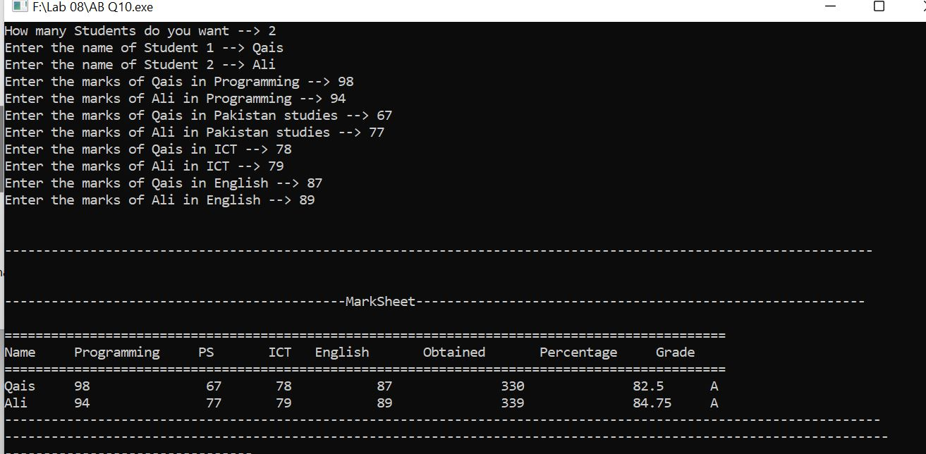

**Task 11**

**#include<iostream>**

**using namespace std;**

**int main()**

**{**

**int size;**

**int min=0,a;**

**cout<<"Enter size of an array : ";**

**cin>>size;**

**int array[size];**

**for(int i=0; i<size; i++)**

**{**

**cout<<"Enter the number : ";**

**cin>>array[i];**

**}**

**min=array[0];**

**for(int j=1; j<size; j++)**

**{**

**if(min>array[j])**

**{**

**min=array[j];**

**}**

**}**

**cout<<"The smallest value in the array is "<<min<<endl;**

**return 0;**

**}**

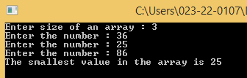

**Task 12**

**#include<iostream>**

**using namespace std;**

**int main()**

**{**

**int size;**

**int max=0,a;**

**cout<<"Enter size of an array : ";**

**cin>>size;**

**int array[size];**

**for(int i=0; i<size; i++)**

**{**

**cout<<"Enter the number : ";**

**cin>>array[i];**

**}**

**max=array[0];**

**for(int j=1; j<size; j++)**

**{**

**if(max<array[j])**

**{**

**max=array[j];**

**}**

**}**

**cout<<"The Largest value in the array is "<<max<<endl;**

**return 0;**

**}**

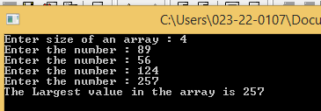

**Task 13**

**#include<iostream>**

**using namespace std;**

**int main()**

**{**

**bool a;**

**int size;**

**cout<<"Enter size of an array : ";**

**cin>>size;**

**int array[size];**

**for(int i=0; i<size; i++)**

**{**

**cout<<"Enter the number : ";**

**cin>>array[i];**

**}**

**int num;**

**cout<<"Enter any number to search in the array --> ";**

**cin>>num;**

**for(int j=0; j<size; j++)**

**{**

**if(num==array[j])**

**{**

**a=true;**

**}**

**else**

**{**

**a=false;**

**}**

**}**

**if(a==true)**

**{**

**cout<<num<<" is Present in array.";**

**}**

**else**

**{**

**cout<<num<<" is not Present in array.";**

**}**

**return 0;**

**}**

